Name ______________________________ HOMEWORK Oct. 24-28
Put your initials by each night that your child practiced the following:
____Monday ____Tuesday ____Thursday
*Nightly Homework*
1. Practice saying letter names and sounds.
2. Count numbers 1-25.
3. Practice assigned Sight Word list in red reading folder.
Name the letters and sounds.
Mm Tt Ss Bb Aa Nn
Dd Cc Pp Ii Rr Ff

Monday: Draw a picture of a word that starts with:
Rr Ff
Circle the correct beginning sound for each word:
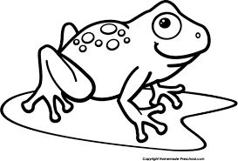
f n r p c n f n b n d p

TUESDAY- Practice writing each spelling word three times.
at sat am

_______________ _______________ _______________

_______________ _______________ _______________

_______________ _______________ _______________

Circle words in the “an” word family.

tan map fan ran dim can big pot pan

THURSDAY- Color the pictures that rhyme.

Can It Fit?

He has a jacket 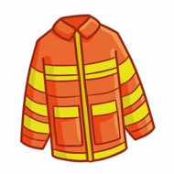 . It is tan.

Can it fit? It can if you pin it!

She has tan gloves 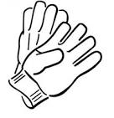.

Can a tan glove 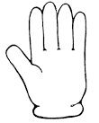fit?

It can fit. It can fit a bit.

He has a helmet .

Can it fit?

Tap the rim. Tip it.

Did it fit?

It did! It did fit.

